Process Document

IPCEI Hydrogen – Match-making Procedure

# Background and Objectives of Match-Making Procedure

The IPCEI Hydrogen was launched by 22 EU Member States and Norway based on a common understanding stipulated in a joint manifesto on December 17th, 2020. Each participating Member State conducted a national call of interest according to its own legal procedures, budgetary and political priorities and timeline. The next step in the process is a European match-making procedure in which the projects are connected with each other to form an IPCEI. The overall objectives of the match-making procedure are to aggregate projects into value chains, to identify and complete the missing links between projects, to formulate concrete targets and contributions and to connect companies according to their preferences. Concretely, the match-making serves the dual purpose of filtering projects for the IPCEI ‘waves’ of notification while simultaneously enabling companies to exchange and cooperate in order to strengthen project concepts which are still in the planning stage. The size and complexity of the IPCEI Hydrogen make the synchronisation of national timelines and political priorities highly challenging. Participating states therefore adopt a pragmatic and consensual approach in mutual decision-making, which is described in the following.

# Involved Actors, Responsibilities and Decision-Making

1. One Member State coordinates the match-making procedure. Germany has agreed to perform the role of Coordinator for at least one IPCEI Hydrogen.
2. The central operational body of the IPCEI process is the Task Force consisting of the Coordinator and representatives from the states participating in the IPCEI process. The Task Force prepares proposals on content and structure of IPCEIs. Task Force proposals are distributed to all states participating in the IPCEI process in a timely manner before joint meetings. The states discuss the proposals and approve or reject based on consensus during meetings for all states participating in the IPCEI process. When consensus is not reached, the Task Force attempts to resolve the dispute with the dissenting state(s) in a bi- or multilateral setting under mediation by the European Commission. If consensus is still not reached, the Task Force has to withdraw and revise its proposal.
3. In order to maintain operability and ensure a streamlined decision-making process, the Task Force should preferably have a limited number of participants. Generally, however, all participating states are invited to join the Task Force. Task Force meetings are open to participation from states, which are not Task Force members on request. DG COMP and DG GROW are invited to join Task Force meetings. Once the IPCEI wave structure is defined, there will be one Task Force for each IPCEI wave of notification.
4. The Task Force recommends to the participating states, which projects should participate in an IPCEI (see Figure 1) after consultation with Member States in which the criteria and reasoning behind the selections and deselection of projects are described**.** Projects can only be recommended to be rejected in agreement with the affected state which selected the project. The final decision of which projects are participating from each state is taken by the state concerned.
5. The European Commission (DG GROW, DG COMP, DG ENER, JRC) closely accompanies and supports the process and provides legal, technical and procedural guidance. All decisions on content, structure and timeline of the IPCEI are prepared by the Task Force. Upcoming Decisions are communicated before Task Force Meetings.

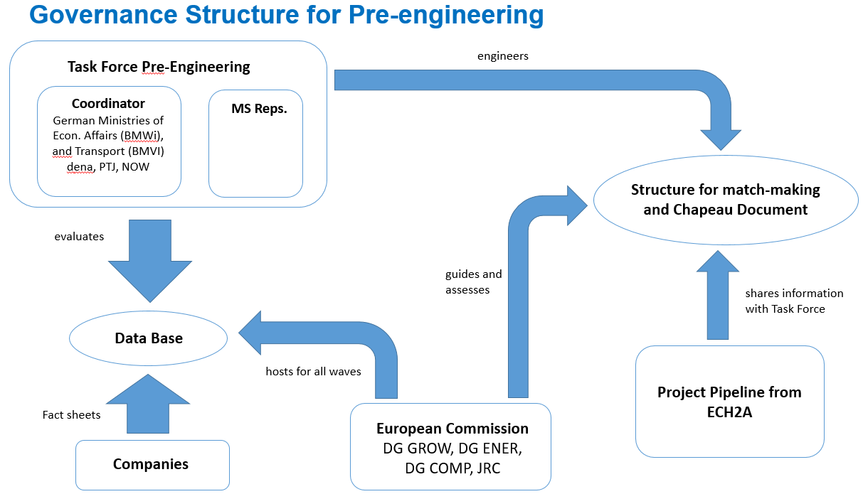

Figure 1: Governance structure for pre-engineering

1. Companies that intend to directly receive state aid under IPCEI are called direct partners. Companies can also be indirect IPCEI partners (e.g. as subcontractors or receiving State aid under other mechanisms (EEAG, RDI Framework, GBER, etc.) meaning they do not apply for state aid funding under the IPCEI Communication. GBER support exempts indirect partners from notification. States decide at national level whether one of their projects is a direct or indirect partner, also in light of the IPCEI requirements. This decision should be made as soon as possible in the process.
2. Match-making will include both direct and indirect partners. This does not affect the principle that participating states have to conduct a thorough pre-selection and can only insert a limited number of projects to the match-making procedure. Challenge Sessions (see No. 17.) include direct partners only.

# The Match-making Procedure

*Pre-engineering, fact sheets, EU survey*

1. The match-making procedure is conducted with all projects shortlisted at national level – direct, indirect and ‘undecided’ partners. In order to ensure a manageable amount of projects for the match-making, participating states have to conduct a thorough national pre-selection in line with the national budget and both national and EU priorities as well as with the IPCEI communication (see Figure 2). Participating states may, if necessary, conduct a final selection process after the European match-making to ensure coordination between national budgets and approved projects by the Task Force (see No. 19.).
2. The first step in the match-making procedure is the so-called pre-engineering. During the pre-engineering, project fact sheets containing non-sensitive information are collected. DG GROW has set up an EU Survey based on the fact sheet template. Companies are obliged to fill out a fact sheet per projecton the EU Survey interface and upload it. Thereby a database containing fact sheets from all nationally pre-selected projects is hosted with DG GROW. DG GROW shares the fact sheets only with the public authorities of all participating states. Fact sheets must be submitted by all companies pre-selected at national level regardless of whether they intend to be direct or indirect partners.

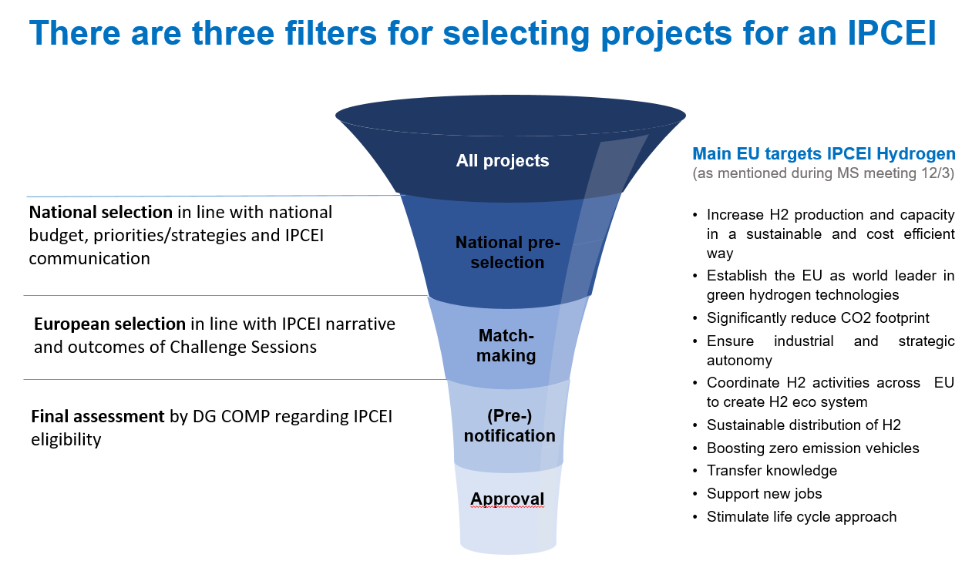

Figure 2: Filters for project selection

1. The fact sheets are scanned and evaluated by the Task Force. Based on this evaluation, an IPCEI narrative and objectives are defined. Criteria for projects responding to these objectives are derived. The project landscape is evaluated bottom-up in order to identify highly mature projects fitting to the IPCEI requirements (such as, but not limited to, spill overs). See also No. 19. on coordination with national final selection processes after the match-making.
2. During the pre-engineering the Task Force also takes into consideration projects that are being collected by the ECH2A, which are expected to comply with IPCEI rules, in view of preparing the project pipeline, in order to identify potential overlaps and synergies (see Figure 1).

*B2match, b2b sessions and Challenge sessions*

1. After registration on EU Survey for the pre-engineering phase, the match-making sessions and B2Bs itself will be conducted on the event platform B2match. Company registration on b2match will be possible from May 10th 2021.
2. The Coordinator forwards B2match registration links for all three participant types (direct, indirect, undecided) to participating states. The states can then forward the respective links to companies depending on whether they are intending to be a direct or an indirect partner or whether that is unclear yet. This categorization only serves as a way to structure the match-making procedure and can be changed. All companies registering to B2match have to submit a project fact sheet (see No. 9.).
3. B2match will provide a platform for companies to engage in 1:1 match-making sessions (b2b sessions) giving them the opportunity to communicate directly on potential cooperation models and lessons learned. Such a format for exchange is valuable both for direct and indirect partners. It helps direct partners to establish the partnerships that form the backbone of an IPCEI. Indirect partners may establish links to direct partners.
4. On B2match, companies will compile a profile in which they can outline the focus of their project(s) and their match-making needs. Company representatives may browse the other participants and engage in virtual b2b match-making sessions. Companies have permanent access to B2match and may engage in b2b sessions at any time. Additionally, companies have access to a ‘marketplace’ where they can display their project in a blog, which other companies may browse.
5. A Kick-off Event to which all alreadyparticipating companies are invited is planned to be held on B2match on May 25th 2021. In this streaming event, the Coordinator and potentially other Member State representatives will welcome the companies and explain the match-making procedure and the desired outcomes. All participants which are invited by the participating states to B2match may participate in the Kick-off Event.
6. A core element of the match-making procedure are so-called Challenge Sessions in which companies from across the value chain formulate their contributions to solve certain challenges deriving from the IPCEI objectives and requirements (such as, but not limited to, contributing to the EU strategies, how to enable spill overs, etc.). Challenge Sessions can only be attended on invitation by the Coordinator. The Coordinator invites companies which are direct partners based on the allocation from the pre-engineering procedure. Members of the Task Force and DG GROW may participate at the meetings.
7. Based on the outcome of the Challenge Sessions and on the IPCEI narrative, the Task Force proposes the project selection and the definition of the different IPCEI ‘waves’ (content and participating direct partners).
8. The project selection and the definition of the IPCEI ‘waves’ defined by the Task Force has to be confirmed by all states participating in the IPCEI-process. Participating states may, if necessary, conduct a process to confirm their intention of allocating national budget to direct partners that have been agreed by the Task Force and all participating states. The European IPCEI process will therefore allow two weeks for a national confirmation process after the European match-making to ensure coordination between national budgets and approved IPCEI projects by the Task Force.

# Timeline, Milestones, Deadlines

1. Acknowledging that more than one IPCEI is necessary to maintain manageability in terms of size, participating states envisage four or more potential IPCEI waves for hydrogen. The final number of potential IPCEIs depends on the number and content of eligible projects pre-selected (information to be derived from the fact sheets).
2. A decision about the coordination of each wave will be taken as soon as the potential number of IPCEIs has been defined.
3. The time line foresees two IPCEIs to be prepared simultaneously in 2021 and notified subsequently. Pre-notification for a Summer IPCEI will begin in Q3 2021 at the latest. The launch of the Summer IPCEI is envisaged for Q1 2022. The time line for the subsequent waves should be as short as possible in order to meet expectations of the companies.
4. In order to enhance the pre-engineering procedure and adhere to the time line, participating states are asked to have their projects submit fact sheets as soon as possible. The deadline for fact sheet submission to be participating in the Summer IPCEI is May 31st 2021. Deadline for participating in the closely following Autumn IPCEI is XX June 2021.