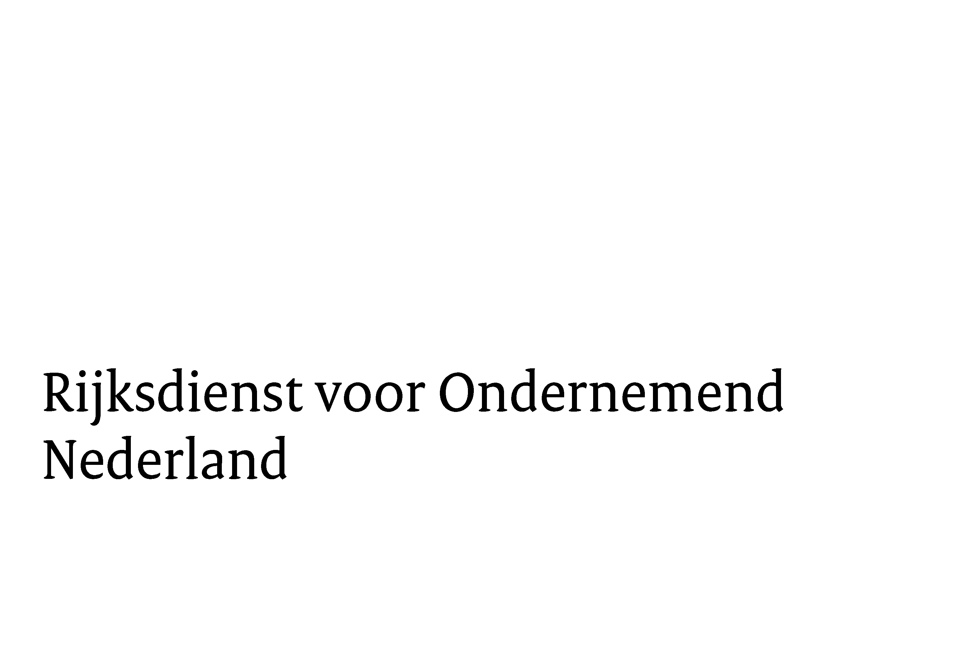


IPCEI on Advanced Semiconductor Technologies | Datum:

Public summary of Expression of Interest
Disclaimer: This information will only be used by European Member States authorities and European Commission to manage and steer the outcomes of the national Call for Expression of Interest in all Member States participating in the IPCEI on Advanced Semiconductor Technologies (IPCEI AST). This information will not be published on websites or other media.

1. Project Title
Project Title

Contact details main applicant
Company name:

Name:

E-Mail:

Type of organization | ☐ SME  ☐ Start-up  ☐ Large entity  ☐ RTO  ☐ University  ☐ Other (please describe):

Member State

Project partner(s) – State yes, when IPCEI-proposals with other Member States’ partners exist or have started  If YES, please select type of partner(s); per category, please specify applicable Member States | ☐ YES ☐ NO  ☐ SME  ☐ Large entity  ☐ RTO  ☐ University  ☐ Other (please describe):

2. Project description
Public summary (max. 100 words)

Keywords (3-5)

Technology Field  (In case more technology fields apply, please fill out a separate form per technology field) | ☐ AI Chips and Accelerators  ☐ Photonic Integrated Circuits  ☐ Chiplets and Heterogeneous Integration/ Advanced Packaging  ☐ Disruptive Sensors for Autonomy  ☐ Power Electronics and Disruptive Energy Solutions  ☐ Secure Communications  ☐ Enabling Technologies (including production- and test machines, materials, electronic design automation, etc.)

Type of Project (multiple answers possible) | ☐ First Industrial Deployment  ☐ Research & Development

3. End Market(s)
European relevance: How does your project strengthen the European microelectronics ecosystem? (max 100 words)

Looking for partners | ☐ YES  ☐ NO

If yes, please describe the type of partner(s) and/or partnership(s) that can be of added value for your project (max. 50 words):

Expected project duration (years)

